10. Photos taken in 2003 after the bushfire and repeated in 2007 and 2013
Four sets of photos were taken at GPS positions (GDA94) according to this table:
Position No. | Easting (GDA) 068…. | Northing (GDA) 608… | Photo direction | Photo identification | Description
1 | 3844 | 6261 | S | a03, a07, a13 | Red and Yellow Box
2 | 3816 | 6226 | NW | b03, b07, b13 | Cattle pond
3 | 3506 | 6135 | S | c03, c07, c13 | Tree stump
4 | 3776 | 6200 | SE | d03, d07, d13 | Fence post hill
Photos are stored under their identification number. Below are copies:

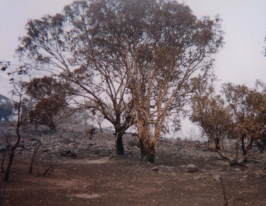
a03
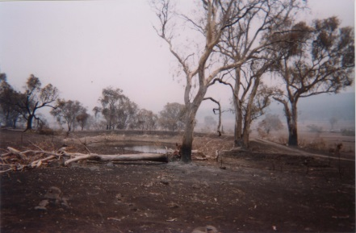
b03
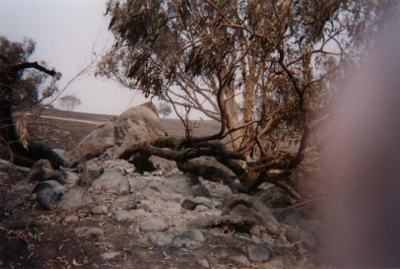
c03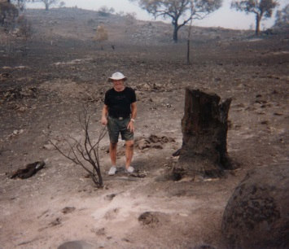
d03
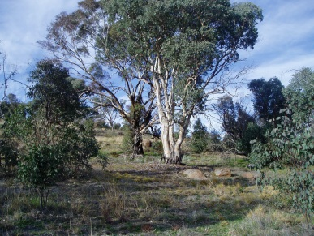
a07
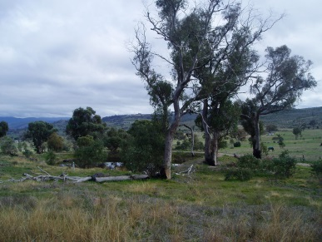
b07
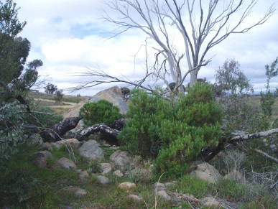c07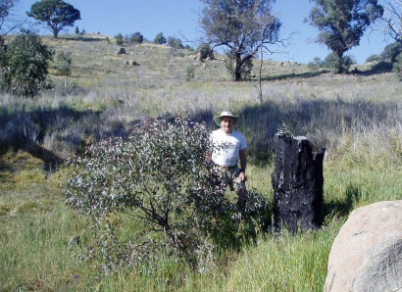
d07
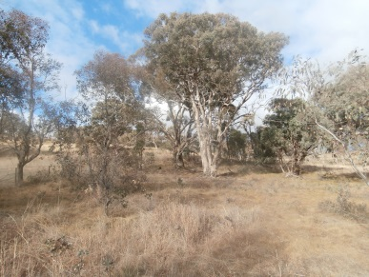
a13
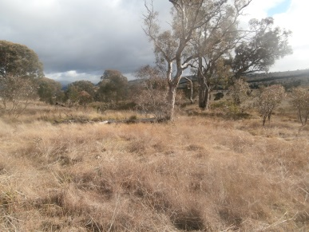
b13
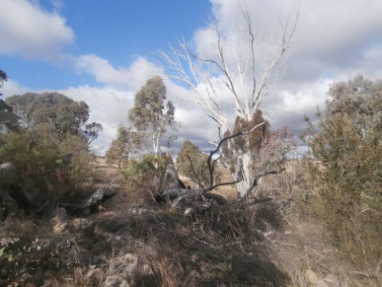
c13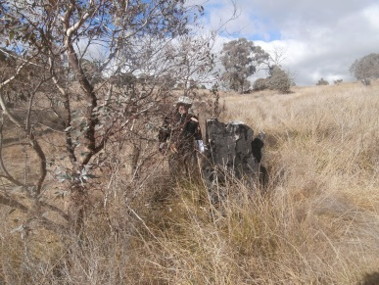
d13

